|  |  |  |  |  |  |
| --- | --- | --- | --- | --- | --- |
| Date | 2-Dec-22 | | | Tester Name | Andrew McLaughlin |
| Environment | Penfax - Test | | | Login used |  |
| Operating System | Windows | Version: | Update: | | |
| Software Used | Edge | Version: | Update: | | |
| Select Software | Version: | Update: | | |
| Release version | 22.4.1 | | | | |
| Title | Data Posting Transaction Header details | | | | |
| Test Type | Regression | | | | |
| Test Scenario | Data Posting Transaction Header details | | | | |
|  |  | | | | |
| Expected Results |  | | | | |
| Pass/Fail | Pass | | | JIRA# | N/A |

Describe your steps with screenshots:

Process a file through DCT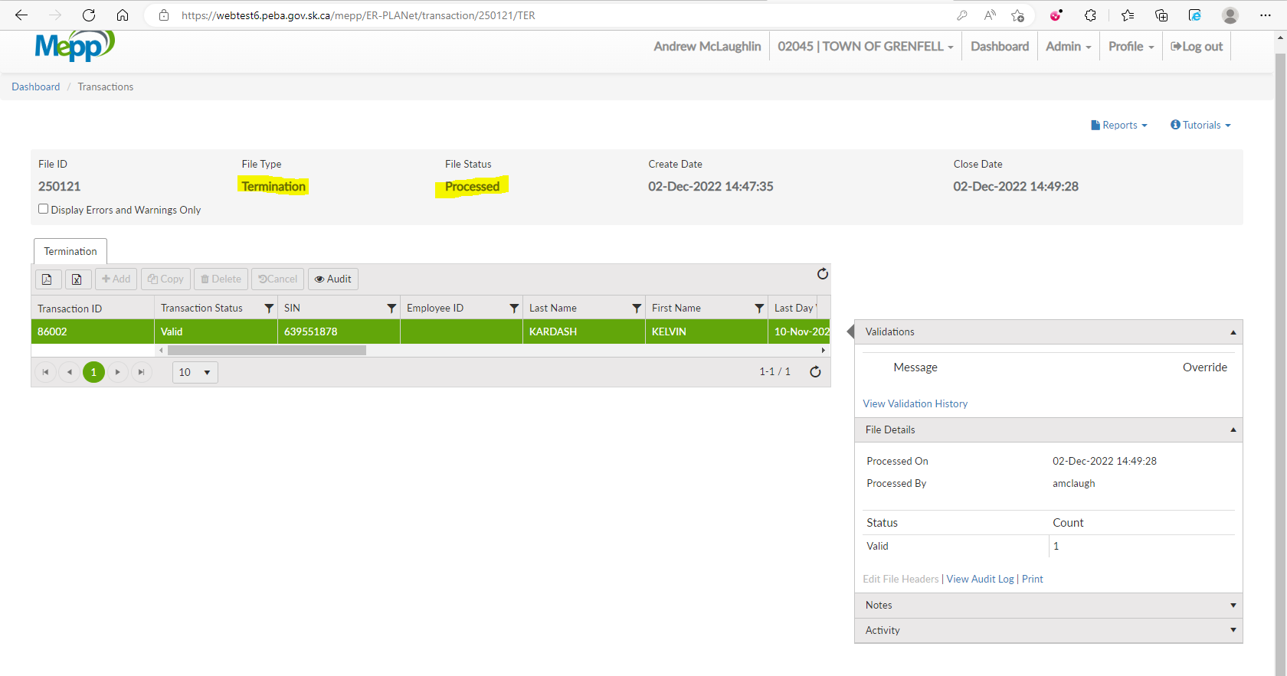

Find the related Data Posting Batch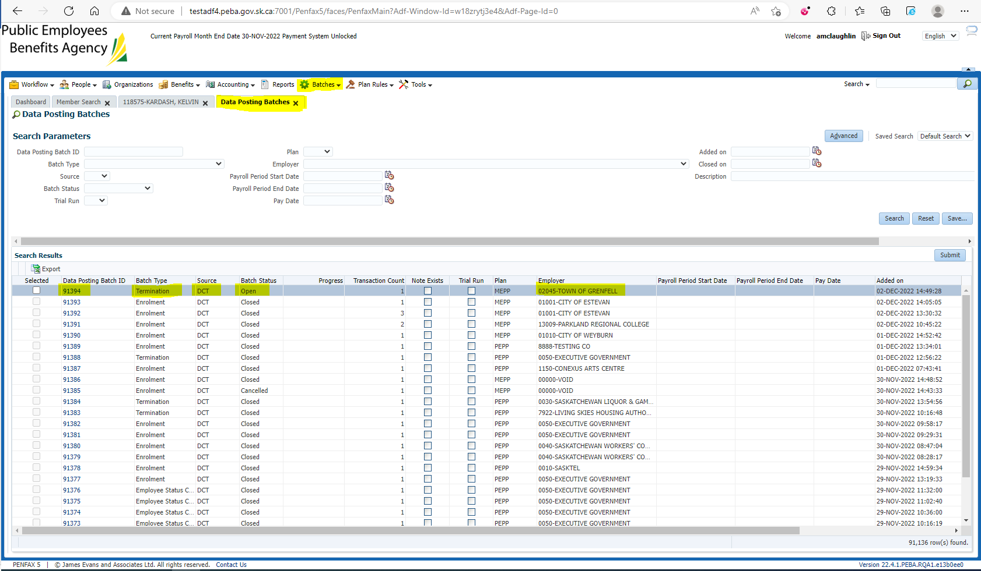

Validate All, Submit All, and open the related Transaction ID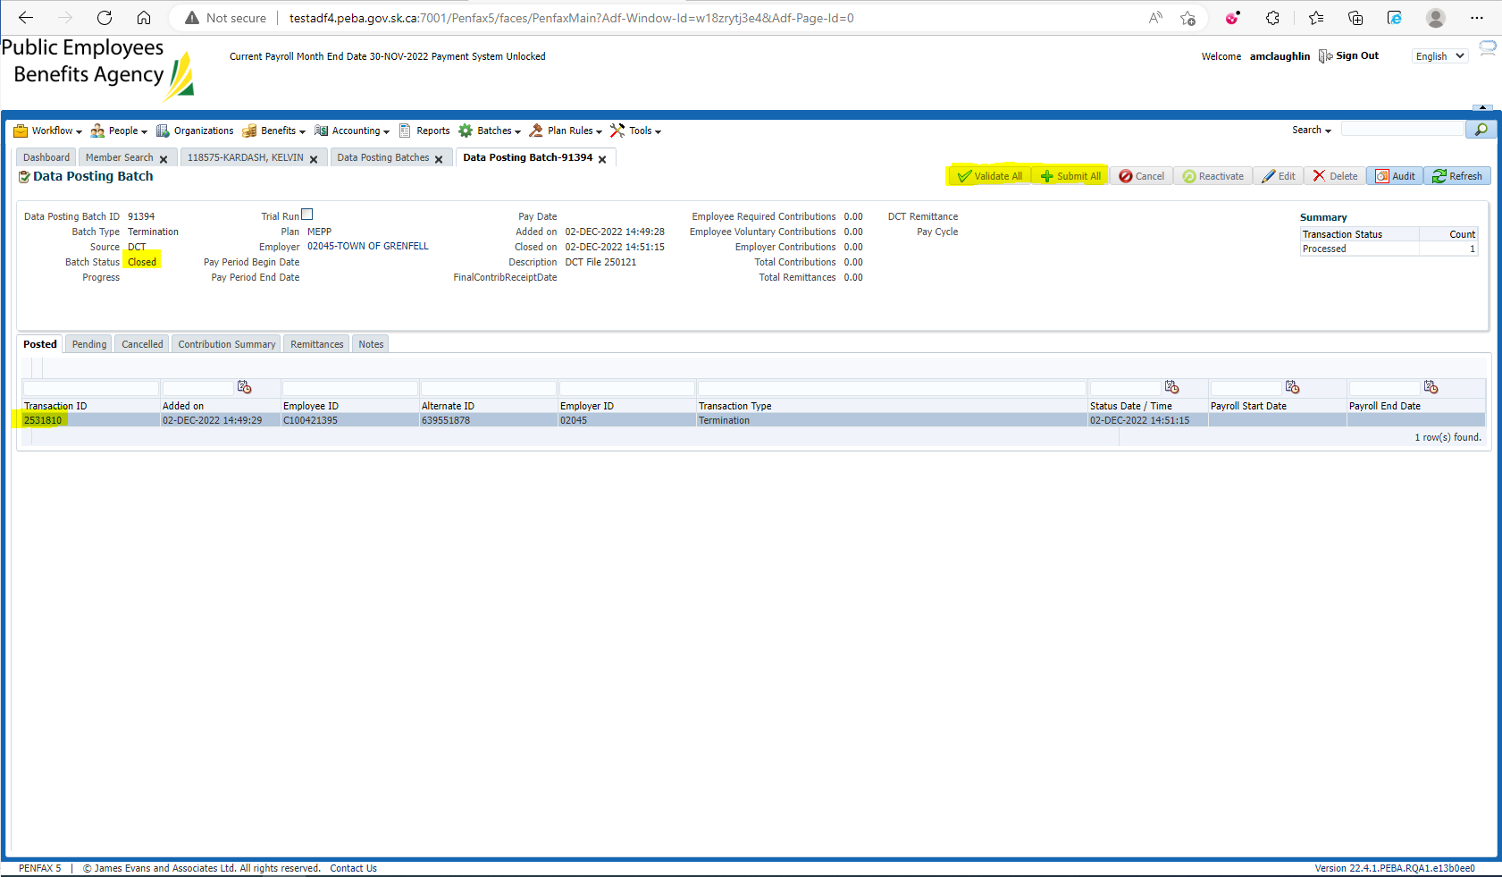

Data Posting Transaction Header details 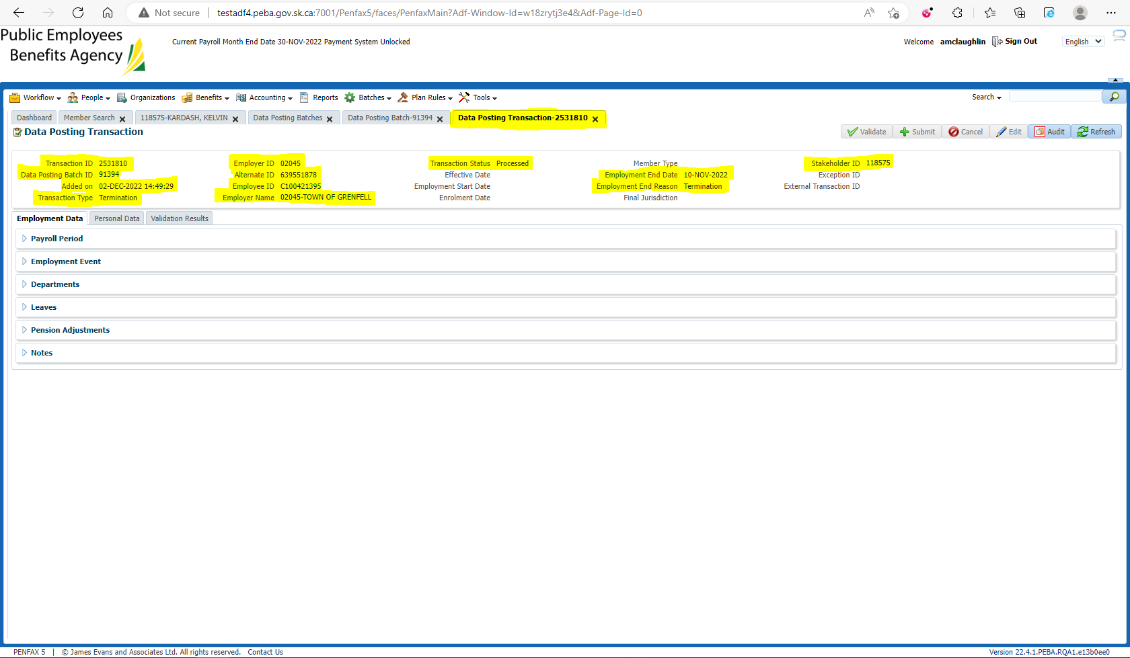

Training Data Posting Transaction Header details match 